The FriendsLook

Marvin Böck marvin.trossingen@web.de

Jan Laffanton

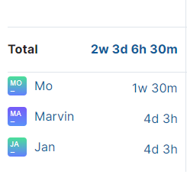Mo

Team Roles:

Marvin -> Implementation/Projekt-Manager/Configuration

Jab -> Implementation,Product Manager, Configuration

Mo->Implementation,Deployment Manager, Configuration

